Software Requirements Specification
for
Library Management System
Version 1.0 approved
Prepared by Feb 09, 2021
1 | 8991 | Usama bin saleem
2 | 9121 | Razi Siddiqui
3 | 10109 | Muhammad Asghar
4 | 9014 | Muhammad Aaqib
5 | 8552 | Syed Naveed Hasnain

<29/07/2020>
Table of Contents
Table of Contents ii
Revision History ii
1. Introduction 1
1.1 Purpose 1
1.2 Document Conventions 1
1.3 Intended Audience and Reading Suggestions 1
1.4 Product Scope 2
1.5 References 2
2. Overall Description 3
2.1 Product Perspective 3
2.2 Product Functions 5
2.3 User Classes and Characteristics 6
2.4 Operating Environment 6
2.5 Design and Implementation Constraints 6
2.6 User Documentation 6
2.7 Assumptions and Dependencies 6
3. External Interface Requirements 7
3.1 User Interfaces 7
3.2 Hardware Interfaces 8
3.3 Software Interfaces 8
3.4 Communications Interfaces 8
4. System Features 9
4.1 System Feature 1 9
4.2 System Feature 2 (and so on) 9
5. Other Nonfunctional Requirements 12
5.1 Performance Requirements 12
5.2 Safety Requirements 12
5.3 Security Requirements 12
5.4 Software Quality Attributes 12
5.5 Business Rules 13
6. Other Requirements 14
Appendix A: Glossary 15
Appendix B: Analysis Models 15
1. Project Backlog………………………………………………………………………….................15
2. Entity-Relationship Diagram………………………………………………………………………15
3. Risk Table………………………………………………………………………………………….16
4. RMMM Plan……………………………………………………………………………………….16
Appendix C: Testing 18

Revision History
Name | Date | Reason For Changes | Version

Introduction

Purpose
“Library Management System” v1.3 is a Desktop based application and is mainly made for use in Library and is the need of every Library in the world. The purpose of this project is to help the librarians keep record of the books available in their library and the books assigned to respective customers. It is also to help the librarians control the inventory of books. It is necessary for a library to keep record of their books and the ones which have been taken by customers. It becomes a very time consuming task to do manually. Also, in huge libraries it becomes hard for people to search books. Therefore, this system is designed in such a way that it will help the owner of library manage librarians and help librarian manage all the activities and things of library. The people will be able to find about the availability of any book by just asking the librarian who will check instantly in the system.
This SRS covers and describes all the parts of “Library Management System”:

Document Conventions
LMS – Library Management System
KIET – Karachi Institute of Engineering & Technology

Intended Audience and Reading Suggestions
The document is specially intended for Faculty of SE (104578), users, developers, Library Owners and documentation writers. The rest of this SRS contains Product Scope, Overall description of the product including use cases, class diagram, User classes, and Operating Environment, User interfaces, System Features and Nonfunctional requirements.
Following sequence is suggested for reading the document:
- Purpose
- Product Scope
- System Features
- Overall Description
- External Interface Requirements
- Nonfunctional Requirements

Product Scope
The Software “Library Management System” mainly made for use in Library and is the need of every library in the world. The purpose of this project is to help the librarians keep record of the books available in their library and the books assigned to respective customers. It is also to help the librarians control the inventory of books. It is necessary for a library to keep record of their books and the ones which have been taken by customers. It becomes a very time consuming task to do manually. Also, in huge libraries it becomes hard for people to search books. Therefore, this system is designed in such a way that it will help the owner of library manage librarians and help librarian manage all the activities and things of library. The people will be able to find about the availability of any book by just asking the librarian who will check instantly in the system. The product’s main goal is to cover all the aspects of a library in such a way that most of the management of library can be done on the system in an efficient and feasible way.
The main objective of the software is to be a bugless, easy-to-use and reliable system to which the librarians and admin can rely on.
The system will be used mainly by the Librarian and will be the power user. While the owner of the Library will be the admin of the system, who will manage librarians and will assign rights of using system to Librarian. The Librarian would be able to manage books like adding them, updating their details, checking the availability of books etc. he will also be able to control the inventory of books. The librarian would also be able to assign and receive books from customers and he will be prompted with fine if a person submitted book after the deadline. Librarian would be able to see assigned books details and the status of books assigned (Received or not received). Librarian would also be able to manage memberships and assign them to customers on the basis of which special discount will be given to customers who are assigned with memberships. He would also be able to generate receipt for customers which will contain details including book name, total amount, discount percentage, price per day of book etc. The system would also be able to generate a report containing information of the number of books taken by customers during a certain period of time and their total amount. The goal is to complete all these features in under 40 days.

References
- Project Scope – Library Management System. (Submitted on GCR Dated: 21st June, 2020)
- Project Backlog – Library Management System. (Submitted on GCR & WhatsApp Dated 6th July, 2020)
- Project Prototype – Library Management System. (Submitted on GCR Dated: 10th July, 2020)

Overall Description

Product Perspective
“Library Management System” is a new self-contained product. It is not a component of a larger system and does not depend on any other software.

Use case Diagram – Library Management System

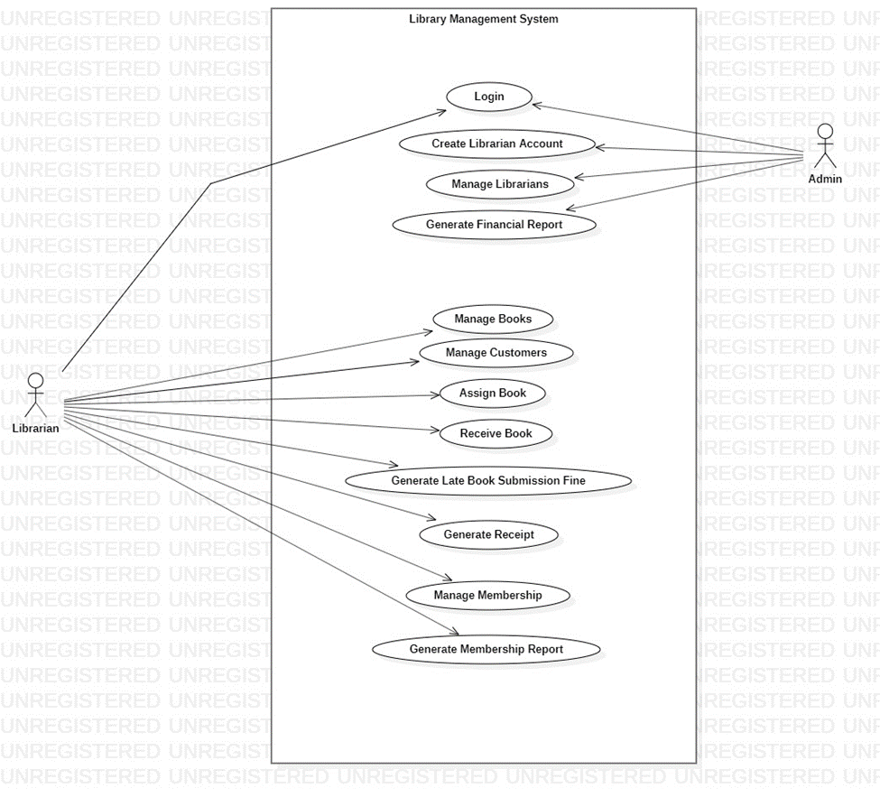

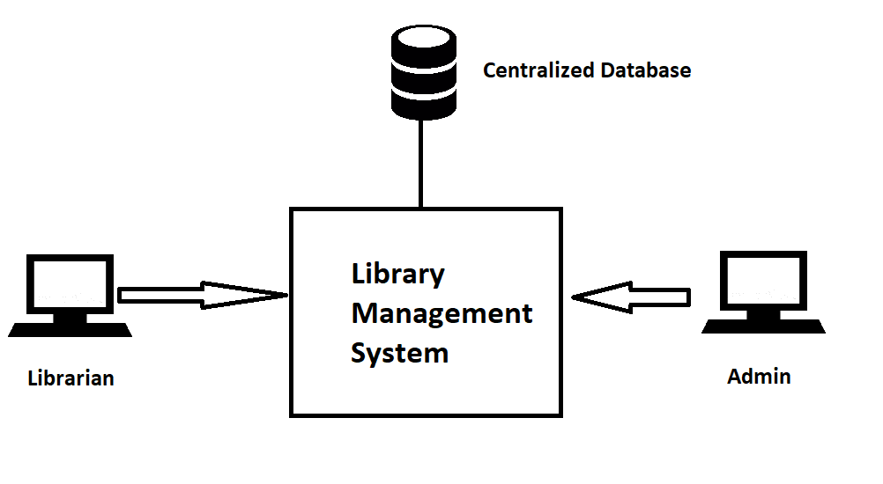

Product Functions
- Book Management
- Customer Management
- Book Inventory Control
- Membership Management
- Membership Report
- Late Book Submission Fine
- Receipt Generation
- Librarian Management
- Financial Report Generation

Class Diagram – Library Management System

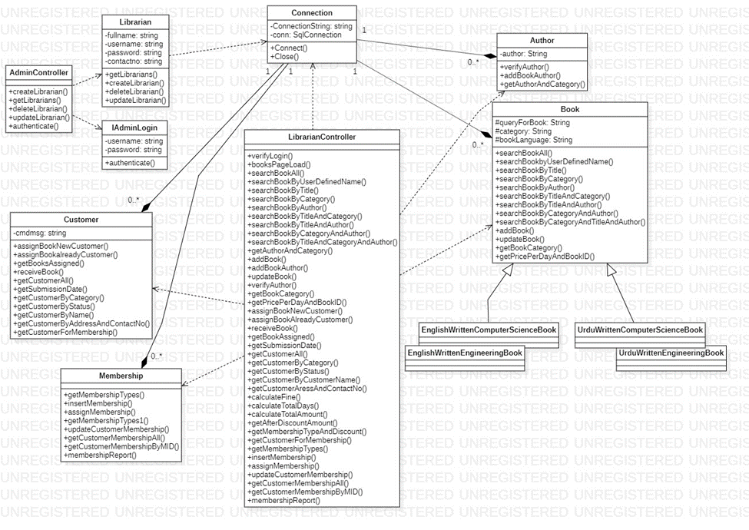

All Diagrams Remaining of library management system:
Activity Diagram --- library management system

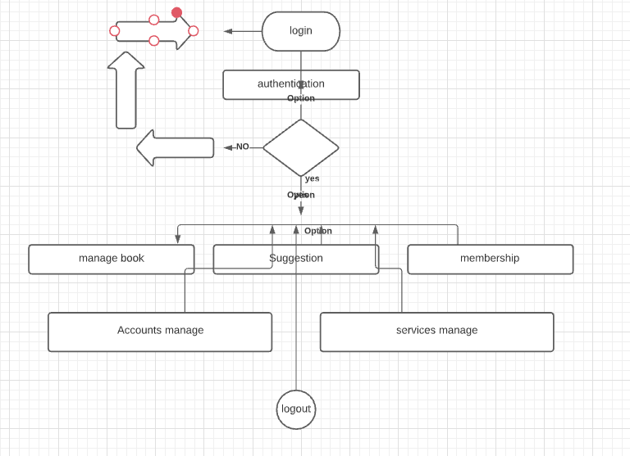

Sequences Diagram --- library management system

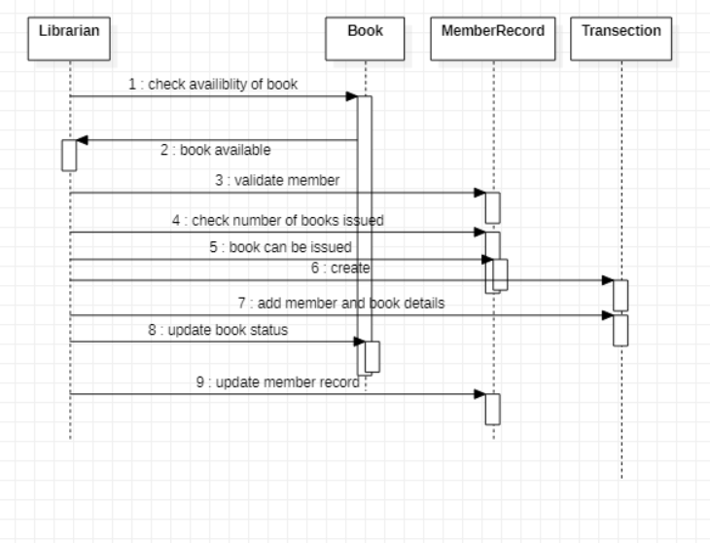

Collaboration Diagram --- library management system
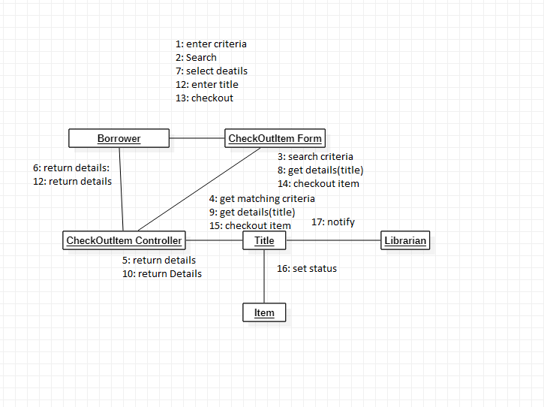

User Classes and Characteristics
Librarian
Librarian will use this software most frequently and will be responsible for and have access to all the functions in the system.

Admin
Admin will not use this software as frequently as Librarian. But Admin will be the power user and can take the rights of using the system from librarian or give the rights to a librarian.

Operating Environment
The LMS software will operate in the Library Environment on a Personal Computer running on Windows 7 or later versions of Microsoft Windows. The Personal Computer must contain Microsoft SQL Server in order to run LMS and support Database.

Design and Implementation Constraints
Deadline (Time)
Due to the deadline so close and the time given to complete the product so less (3 months). The developers will face difficulties in implementation of all required functionalities.

User Documentation
- Tutorials in video format will be delivered along with the software.

Assumptions and Dependencies
Instructor Influence
The requirements stated in the SRS can be affected if the instructor wants something else in the system.

2.2.2 Function Descriptions (Functional Requirement Listings)

2.2.2.1 Log In Function

Description: This function ensures that only authorized users gain access to the LMS databases. An authorized user is a user who has an account on the system. Users include students,teachers. The user must type a valid username and password to gain access.

2.2.2 Module 1: book Manage

Description: This function allows admin to add book data which import from different country. Admin can delete books and update information of book.

2.2.3 Module 2: manage services/ customer

Description: This function allows user to get services about new books. Admin can [Make | Drop | View | Update] services.

2.2.4 Module 3: Account manage

Description: This function allows user to give account about new books. Admin can [Make | Drop | View | Update] accounts.

2.2.5 Module 4: manage membership

Description: This function allows user to get membership. Admin can [Make | Drop | View | Update] membership.

2.2.6 Module 5: suggestion manage

Description: This function allows user to give suggestion about new books. Admin can [Make | Drop | View | Update] suggested ideas.

External Interface Requirements

User Interfaces
“Library Management System” is a Desktop based application for usage in Library and to reduce the effort required by Librarians to manage book inventory and records of Library.
In order to make all the tasks feasible and to reduce the time required to perform respective tasks. User Interfaces have been designed in such a way which makes it easy, efficient, and enjoyable for the Librarians and Admin of Library to operate the system.
Certain GUI standards have been followed in the design of interfaces. Screen layout have been kept simple as possible. Such colors have been used which maintain the aesthetics of the interface. Standard buttons have been used of 2 different designs (one for major operations and one for navigation).

The diagram below demonstrates the interaction from one user interface to another. This is a brief description. However, a more detailed demonstration is done in the Project Prototype (Submitted on GCR).

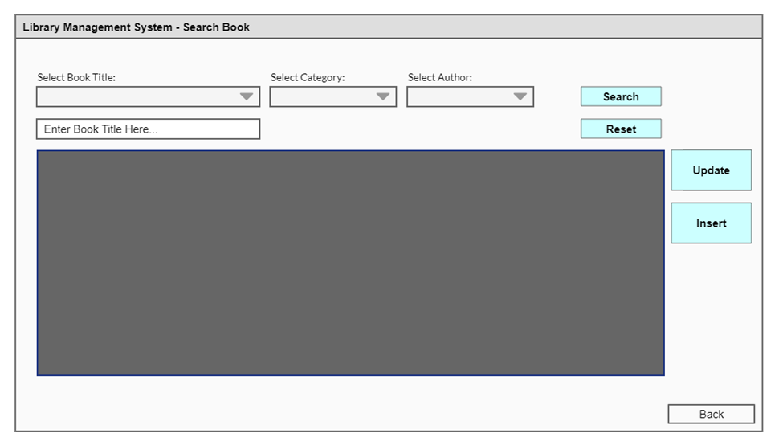

Hardware Interfaces
The “Library Management System” Will run on PCs of Librarians and Admin and the Centralized database will be placed on one of the system inside the library. All the systems using LMS will be connected to the centralized database through LAN.

Hardware requirements are
- Intel Core Processor
- 2 GB Ram
- 5 GB Hard drive (Excluding the space required for Operating System).
- Local Area Network
- Ethernet Connection.

Software Interfaces
Microsoft SQL Server 2012 or Latest
Microsoft SQL Server is a relational database management system developed by Microsoft. As a database server, it is a software product with the primary function of storing and retrieving data as requested by other software applications—which may run either on the same computer or on another computer across a network.
LMS will Microsoft SQL Server for its database and it must be installed on the centralized database’s system and all the other systems through which the system will be operated.
Microsoft .NET Framework 4.0 or Latest
.NET Framework is a software framework developed by Microsoft that runs primarily on Microsoft Windows. It includes a large class library called Framework Class Library and provides language interoperability across several programming languages.
.NET Framework is necessary because its libraries have been used in the Library Management System. So, .NET Framework must be installed in all the systems through which LMS will be operated.
Microsoft Windows 7 or Latest
Microsoft Windows, commonly referred to as Windows, is a group of several proprietary graphical operating system families, all of which are developed and marketed by Microsoft. Each family caters to a certain sector of the computing industry.
LMS will be able to run smoothly on Microsoft windows 7 or latest.

Communications Interfaces
No Communication Interfaces.

System Features

Librarian Management
4.1.1 Description and Priority
The Admin of the system (Owner of the library) would be able to manage librarians and can assign them authority to use the functions of Library Management System.
Priority: 9
4.1.2 Functional Requirements
REQ-1: Create accounts for librarians through which librarian can access the features of LMS
REQ-2: Search librarian accounts by name.
REQ-3: Update Librarian Account Details.
REQ-4: Delete Librarian Account.

Librarian Login
4.2.1 Description and Priority
Librarians would have accounts and they will be able to login into the system.
Priority: 5
4.2.2 Functional Requirements
REQ-1: Password and username verification.
REQ-2: Login and provide access to functions of LMS to Librarian.

Book Management
4.3.1 Description and Priority
The system will provide features through which books will be managed by Librarian(s). Books can be searched, added, updated, and controlled in terms of inventory.
Priority: 8
4.3.2 Functional Requirements
REQ-1: Add Book into the system along with certain details i.e. quantity, price per day, author, and name etc.
REQ-2: Update Book Details.
REQ-3: Search book by name, author, or category.
REQ-4: Control Book Inventory

Customer Management
4.4.1 Description and Priority
The Librarian will be able to assign available books to customer (new or old) and receive books from them. The Librarian can also see the history of books assigned including books assigned and returned, books assigned and not returned yet.
Priority: 8
4.4.2 Functional Requirements
REQ-1: Assign Book to Customer (New or Existing)
REQ-2: Receive Book from Customer.
REQ-3: View Assigned Books (Returned and not returned).

Book Inventory Control
4.5.1 Description and Priority
Inventory of the books would be managed in the system. Quantity of the books can also be altered.
Priority: 8
4.5.2 Functional Requirements
REQ-1: Alter inventory of Book(s).
REQ-2: Prompt to Librarian when Book quantity is zero.

Membership Management
4.6.1 Description and Priority
The system will have some membership types (Gold, silver etc.) on the basis of it discount will be provided to the customers on respective book rent. The membership types can be added also. The librarian would also be able to assign membership to already registered customers or new customers. The members can also be searched on the basis of their name or membership type.
Priority: 7
4.6.2 Functional Requirements
REQ-1: Assign Membership to Customer (New or Existing)
REQ-2: Add New Memberships
REQ-3: Update Membership Details.
REQ-4: Calculate and provide discount to customer on respective book rent.
REQ-5: View Members Details on the basis of their name or membership.

Membership Report Generation
4.7.1 Description and Priority
The system will be able to generate a membership report containing details related of the number of customers having respective memberships.
Priority: 6
4.7.2 Functional Requirements
REQ-1: Report format
REQ-2: Count and show number of customers in each type of membership.

Late Book Submission Fine
4.8.1 Description and Priority
On the time of submission of book, the system will be able to calculate and show fine when a customer doesn’t return the book before submission date.
Priority: 6
4.8.2 Functional Requirements
REQ-1: Calculate Fine.
REQ-2: Prompt Fine to the librarian at the time of submission

Customer Receipt Generation
4.9.1 Description and Priority
The system will also be able to generate receipt for customer containing book name, total amount, discount percentage, price per day of book etc.
Priority: 7
4.9.2 Functional Requirements
REQ-1: Calculate total amount
REQ-2: Calculate discount if applicable and show the payable amount.

Financial Report Generation
4.10.1 Description and Priority
The system would be able to generate a report containing information of the number of books taken by customers during a certain period of time and combined total amount. Financial report can only be generated by the Admin of the System.
Priority: 6
4.10.2 Functional Requirements
REQ-1: Calculate total number of books taken during certain period.
REQ-2: Calculate total amount (Payable and Received) of books taken during certain period.

Other Nonfunctional Requirements

Performance Requirements
Capacity: Performance of LMS will be measured in terms of capacity when heavy data would be stored and what is capacity of the total system itself. Centralized Database would be beneficial when the system would be accessed from different systems at the same time and everyone would get the updated data.
Response Time: Response should be very fast (less than or equal to 1ms) as LMS will be running on a LAN environment and centralized database would also be connected to LAN.

Safety Requirements
As LMS will contain all the important information of library related to Librarians, Books, Customers, and Memberships so this thing is to keep in mind that system containing centralized Database should be kept safe and not be altered or go in unauthorized hands. Backup of database should be maintained using cloud services. So, in case if database get lost it is restored through backup Database.

Security Requirements
The admin panel should not be accessed by anyone except the owner of the Library so special login system will be implemented for Admin also.
The authority to use the LMS will only be given by the Admin of the system who will create an id for librarian through which librarian can login into the system using password authentication.

Software Quality Attributes
Portability
The system can run on almost all the systems which are around nowadays.
Robustness
The system cover all the boundary areas of certain fields and it will prompt the users on wrong inputs. It will be able to handle all kinds of inputs.
Availability
The system will available 24/7 as it will run on Local Area Network.
Usability
The users will enjoy and feel easy while using the UI of LMS which is simple looking and is quite aesthetic.
Maintainability
The maintainability of LMS would be easy and done in no time as the system is build using concepts of OOP and GRASP Principles.
Requires Less PC Resources
The system is light weight and doesn’t require huge amount of memory or Processing power.

Business Rules
Admin
Admin would be able to manage librarians and create accounts for them through Librarians would be able to access the functions of LMS. Admin would also be able to search Librarians and update their account details.
Librarian
Librarian would be able to access all the functionalities related to the management of books, customers, and memberships.

Other Requirements

Operating System
LMS, as it’s a Desktop based application should support following Operating Systems:
- Windows 7
- Windows 8
- Windows 10

Programming Language
LMS should be implemented using C# (C Sharp).

Software Reuse
LMS can be reused in all the libraries of the world.

Appendix A: Glossary
Same as 1.2 (Document Conventions).
Appendix B: Analysis Models

- Project Backlog
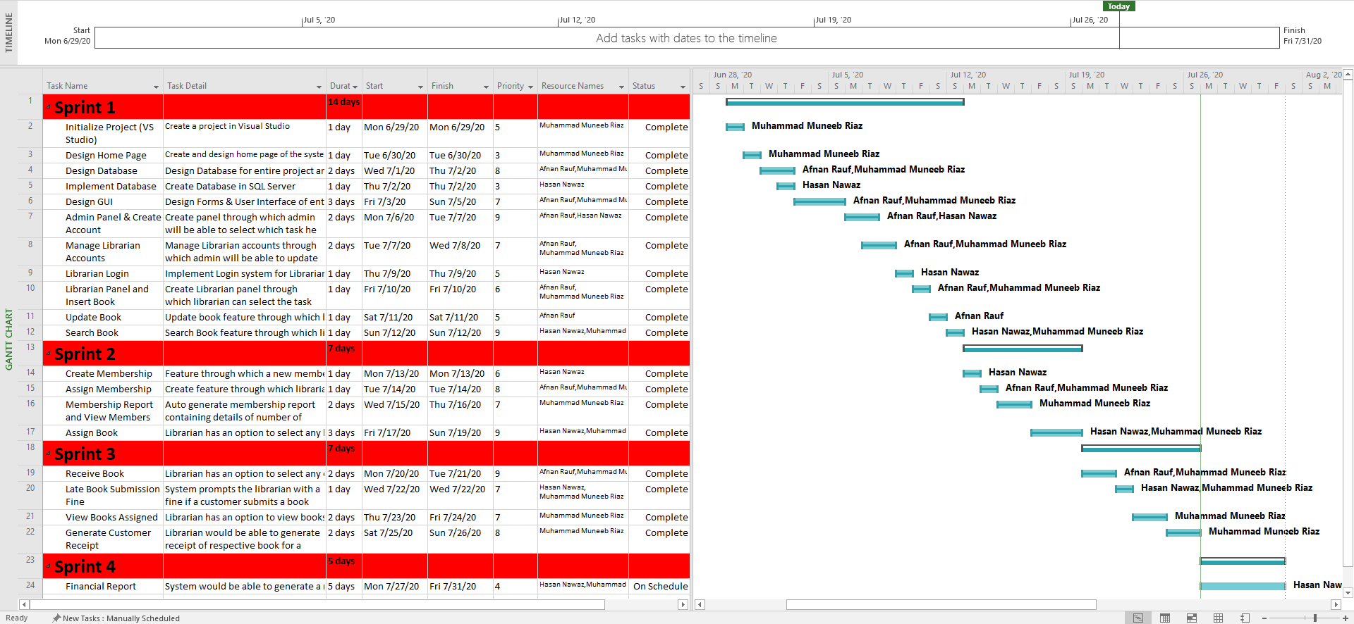
- Entity-Relationship Diagram
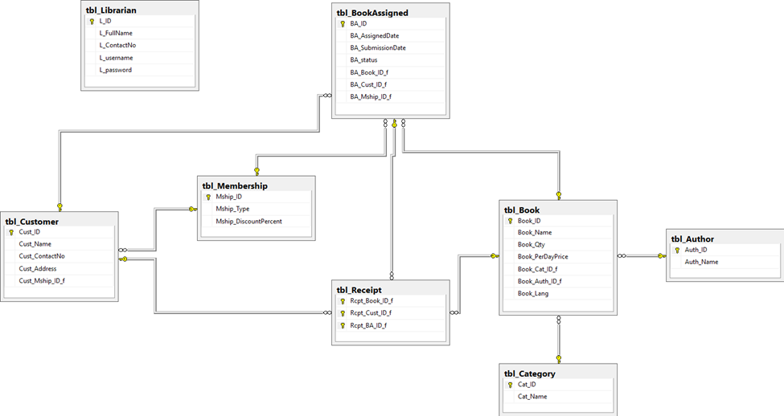
3. Risk Table
No. | Risk | Probability | Impact
01 | Database gets Lost | 10% | 5
02 | Incomplete Implementation of Financial Report | 50% | 2
03 | End User Resist System | 20% | 3
04 | End Users find UI user-unfriendly. | 1% | 2
4. RMMM Plan
Risk 1: Database gets lost.
- Mitigation
To prevent the loss of data, a backup of database will be maintained and updated on cloud, so that database can be restored whenever required.
- Monitoring
The meetings with the development team and clients would ensure the requirement of database storage and cloud services would be availed according to the requirement.
- Management
Should the system containing the centralized database be corrupted or get lost, respective database will be quickly recovered through cloud service.
Risk 2: Incomplete Implementation of Financial Report due to shortage of time.
- Mitigation
In order to prevent this from happening, UI Design would be kept as simple as possible, so that some time is saved and the time which is saved would be utilized for complete implementation of financial report feature.
- Monitoring
The software will be developed with deadline in mind. Software will also be tracked during development using MS Project. So that it is known that each milestone is being achieved before time or after it, which will also determine the likeliness of the risk.
- Management
Should the deadline arrives and the implementation of Financial report feature is incomplete, the product will be delivered without it and the feature will be delivered later in the next increment.
Risk 4: End Users find UI user-unfriendly.
- Mitigation
In order to prevent this from happening, the software will be developed with the end user in mind. The user-interface will be designed in a way to make use of the program convenient and pleasurable.
- Monitoring
The software will be developed with the end user in mind. The development team will ask the opinion of various outside sources throughout the development phases. Specifically the user-interface developer will be sure to get a thorough opinion from others.
- Management
Should the User Interface be resisted by the end user, the UI of the entire system will be thoroughly examined to find the reasons that this is so. UI will also be investigated and if necessary, revamped into a solution.

Appendix C: Testing
Test Case No.01
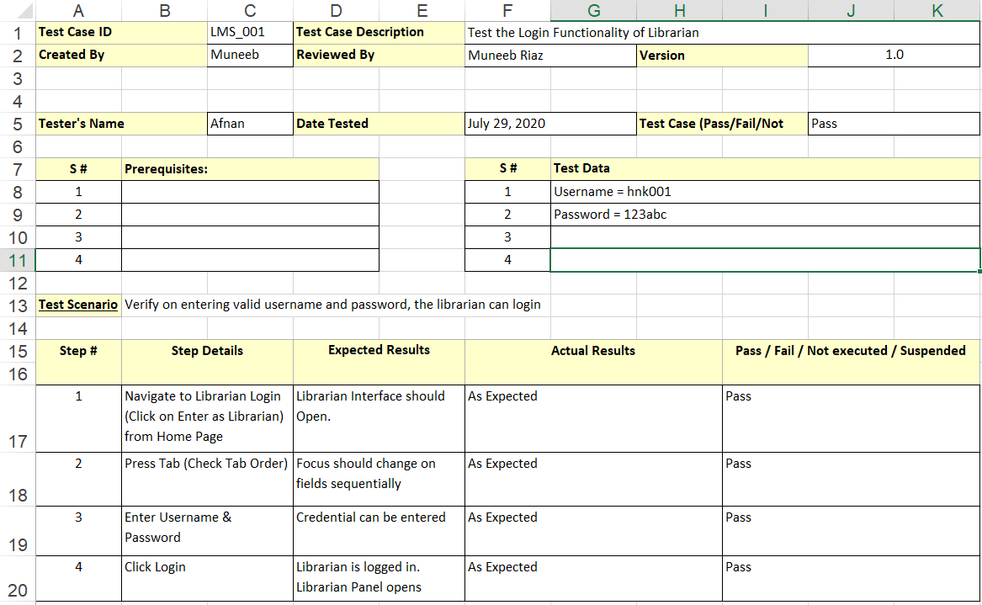

Test Case No.02
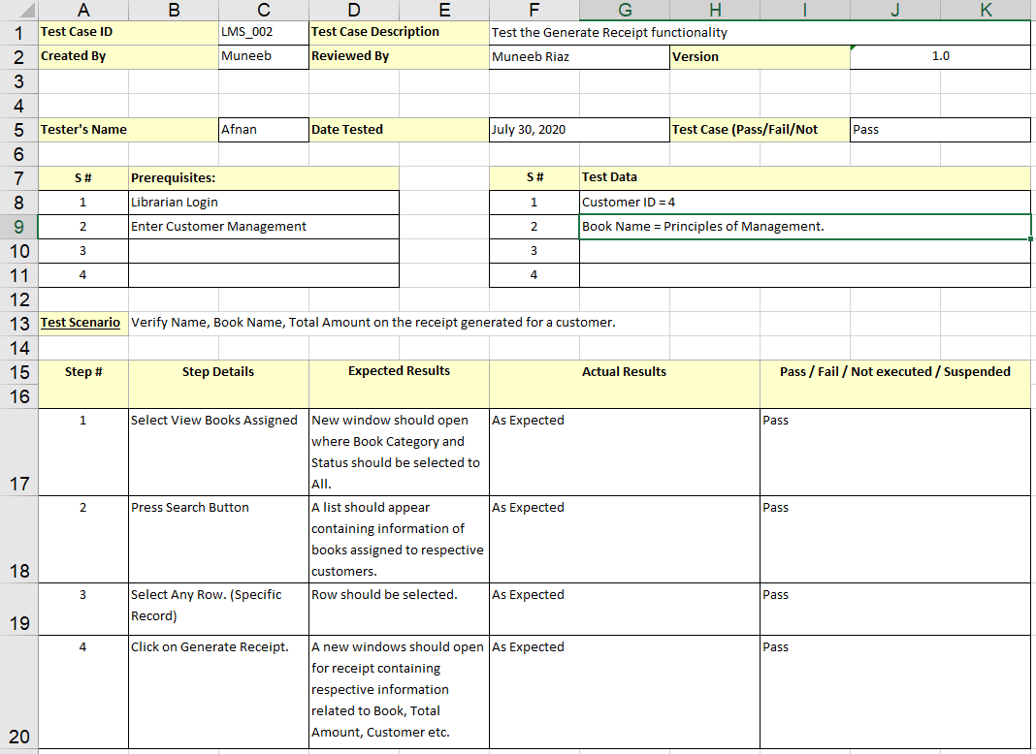

Test Case No.03

